Statistics: The Science of Decisions Project Instructions

Background Information
In a Stroop task, participants are presented with a list of words, with each word displayed in a color of ink. The participant’s task is to say out loud the color of the ink in which the word is printed. The task has two conditions: a congruent words condition, and an incongruent words condition. In the congruent words condition, the words being displayed are color words whose names match the colors in which they are printed: for example RED, BLUE. In the incongruent words condition, the words displayed are color words whose names do not match the colors in which they are printed: for example PURPLE, ORANGE. In each case, we measure the time it takes to name the ink colors in equally-sized lists. Each participant will go through and record a time from each condition.

Questions For Investigation
As a general note, be sure to keep a record of any resources that you use or refer to in the creation of your project. You will need to report your sources as part of the project submission.

- What is our independent variable? What is our dependent variable?

Independent: The word and color displayed.
Dependent: Reaction time

- What is an appropriate set of hypotheses for this task? What kind of statistical test do you expect to perform? Justify your choices.

1. Set of Hypotheses
Null Hypotheses: Color and word pairing has no effect on the time to say correct word. μ congruent = μ incongruent
Alternative Hypotheses: Color and word pairing mismatch raises the time to say correct word. μC < μI

2. Statistical Test
I will use a t-statistic since the sample size is less than 30. Also, we do not know the population means of congruent or incongruent tests.

3. Justification For Statistical Test
The sample trials are paired/dependent. The same person does each test.

- Report some descriptive statistics regarding this data set. Include at least one measure of central tendency and at least one measure of variability.

Congruent Mean Time from Data Set: 14.051
Congruent Standard Deviation from Data Set: 3.559

Incongruent Mean Time from Data Set: 22.016
Incongruent Standard Deviation from Data Set: 4.797

- Provide one or two visualizations that show the distribution of the sample data. Write one or two sentences noting what you observe about the plot or plots.

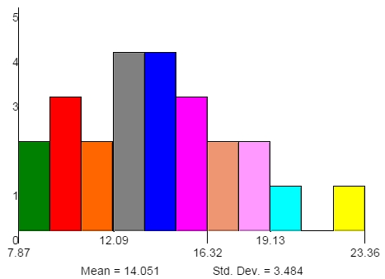
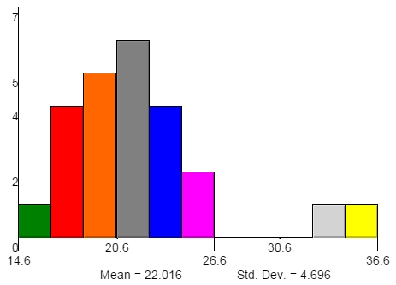

The standard deviation was much higher with the incongruent test. This might suggest there was a wider variance of people's ability to complete the project.

The mean time for the incongruent test was significantly higher. This would suggest the test was more difficult for people to perform and/or require more concentration.

- Now, perform the statistical test and report your results. What is your confidence level and your critical statistic value? Do you reject the null hypothesis or fail to reject it? Come to a conclusion in terms of the experiment task. Did the results match up with your expectations?
μC: 14.051 μI: 22.016
σC: 3.559 σI: 4.797

SD(congruent) = 3.559/sqrt(24) = 0.726
SD(incongruent) = 4.797/sqrt(24) = 0.979

Confidence Level:
M +/- 1.96 * SD
95% congruent → 14.051 +/- 1.96* 0.726 → (12.628, 15.474)
95% incongruent → 22.016 +/- 1.96 * 0.979 → (10.097, 23.935)

T-Statistic:
t = (μC – μI)/ ( (σC – σI) / sqrt(n) )
t = (14.051 – 22.016)/( (3.559 – 4.797) / sqrt(24) ) = 31.519

T-Critical for alpha = 0.05 and 23 degrees of freedom is 1.714 for a one-tailed distribution.

The t-statistic is much larger than 1.714. Thus, we reject the null hypotheses. It's clear that when the color does not match the word it takes longer to read it correctly.

- Optional: What do you think is responsible for the effects observed? Can you think of an alternative or similar task that would result in a similar effect? Some research about the problem will be helpful for thinking about these two questions!

The average brain processes visual characteristics in greater force than recognition of the actual word. Thus, when they do not match there is an error.

Another test that could be run is to show an animal and the name of the animal. First test would be to match the animal with the picture (e.g. picture of a rhino with the word “rhino”). Second test would be to mismatch the word and picture (e.g. picture of a rhino with the word “giraffe”). Time the duration to say the correct word. Then examine the differences in time to say the correct word.

